2022 Fall CPSC 240 Semester Review

The topics are ordered in the same sequence as found in the text book.

This is only an outline. During the lecture you are welcomed to enter notes after each topic heading.

C1: Why do we learn assembly programming?

To learn architectures (components)
to learn tool chain (all the tools used to develop a program)
loader ;built in operating system function called whenever you use ./
to learn what happens during function calls (memory management)

C2: Architecture
ALU, GPR, SSE, cache, CPU, memory, bus, components, clock

rflags – whenever a math instruction is successful the rflag is changed from 11-bit to 0-bit; from 1-bit to 11-bit if unsuccessful.
Cache – von neuman
lsb, msb, endian
how memory is organized
stack (high)
heap
--------------------------------
BSS – uninitialized data
--------------------------------
text (code)
--------------------------------
reserved (low)

AR
when a new func is called rip is saved into the frontend of the previous AR and rbp of the previous AR is saved into the

C3: Data
Twos complement, IEEE754, unsigned int, signed int, 64-bit numbers, 32-bit numbers
twos complement only applies to integer data
25127 in 8’s compliment. Find negative
flip and add 1
0 1 2 3 | 4 5 6 7
52650
+1
= 52651
unsigned ints
conversions
how to find max unsigned integers
how to find max twos complement integers
how to find min twos complement integers
IEEE754
base, bias, stored exp, true exp, +/- infinity, nans
smallest positive normal #
largest positive normal # (can write code using printf to output this number; will be very big number [~300 digits before decimal]
Conversions between decimal floats and IEEE
32-bit and 64-bit

C4: Source code format
Nasm does not enforce the layout of source code. Most programmers in the profession follow a common universal layout. We followed that in 240.
db, dd, dw, dq, resq, resd, resb, resw

C5: Tool chain
Know the programs used to bring a program from conception to delivery.
Editor, compiler, assembler, linker, debugger, loader
bash files assembles, links, and compiles for you
text
linux – LF (we used this)
MAC – CR
Win – CRLF
3 linkers
what happens if no -o flag (ex: -o sort.o)
omit dynamic link
omit sample script file
ELF64 – format wanted when -o flag is used (?)
what is a list file?
Shows what is happening during compilation (?)

C6: GDB
There were more lectures on this topic than any other single topic.
Know all the commands used in class lectures.
Omit DDD. Source, set-logging, where
Phase 1: viewing data
how many quad words in current AR?
p/d ($rbp-$rsp)/8 + 1 ;change d to f if asking for doubles
x/1xg ($rbp+8) ;dereference 1 hex giant word (rbp + 8, the frontend quadword at the previous AR) - gets the rip from the previous AR

Phase 2: changing data
what is the GRB command that will change the value of (double cost = 3.55) to 9.99?
What GDB command will make the 5th element in an array (score resq 25) hold the value 36?

C7: All the assembly instructions used in this class
The list is very extensive. Chapter 7 has many instructions
omit lea, movsx, movzx, adc, loop
p.77 (expanding a number)
cbw(convert byte(?) to word), cwd(convert word to double), cdq(convert double to quad), cqo(convert quad to octal)
rax – 8 bytes
eax – 4 bytes
ax – 2 bytes = word
al – 1 byte

cdq:
we have
mov r15d, 187 ;4 bytes
mov eax, r15d
cdq
;then, edx:eax is the same number, but more bits ;edx combined with eax

cdqe ;~e puts answer back in one register instead of having a combined pair of registers
mov eax, 7542
cdqe
;answer is in rax completely, no pair/combination of registers
cwde
cbwe
Example:
input # with scanf
ctrl-d
scanf puts -1 in eax
cdqe
extends -1 to rax
cmp rax, -1

add
sub
imul - signed
mul - unsigned
div
idiv

cmp, uncomisd
jg, jge, jl, jle, je, jne – used for 2 complement ints
ja, jae, jb, jbe, je, jne – used for xmm and unsigned ints

shl, shr
shl rax, 12 ;shifts to the left by 12 bits

sign 11-bits mantissa
shr rax, 52 ;shifts to the right by 52-bits, left with stored exp (sign 11-bits)

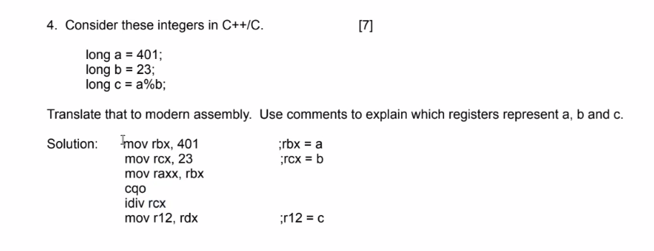
rax%rcx = rdx (remainder) ;rax will have quotient
numerator before idiv, denominator after idiv
C8: Address modes
Know what register, memory, and immediate are all about.

Add rax, [rsp] ;rax is register, [rsp] is memory
sub rax, 8 ; 8 is immediate
mov [r8 + 8 * r12 +6], 35 r8 and r12 are registers, 6 and 8 are immediate, everything in [] is memory

C9: The system stack. You have made many programs the use this stack. You know a lot about this subject. Know how to add extra qwords to the stack without using the push instruction. Know how to read or modify a quadword inside the stack without popping.

Push and sub are the same
pop and add are the same

sub rsp, 64 ;counters 8 pushes

movsd xmm9, [rsp + 32]

C10: Program development
Chapter 10 proposes to teach how to get started on a programming project and how to continue developing it until the program meets all the requirements. You have all completed 3 semesters of intensive C++ programming, and therefore, you are highly competent programmers in general and in C++ specifically. We’ll omit the details of Chapter 10.

C11: Macros. Not on this test.

C12: How function calls work.
This semester a lot of time was spent on the actions underlying a function call. If we know how a function call works, then we also know how a function return works.

Word “dynamic” will not be on the test because of conflicting definitions
double function(long, double){
double x;
long y;
char name[22];
//C++ calls these dynamic

double *a = new double[16};
//this is dynamic, but not according to C++
}

parameter passing
preserved registers and returns
rdi, rsi, rdx, rcx, r8, r9, push any other registers onto the stack (in reverse order; last in, first out)
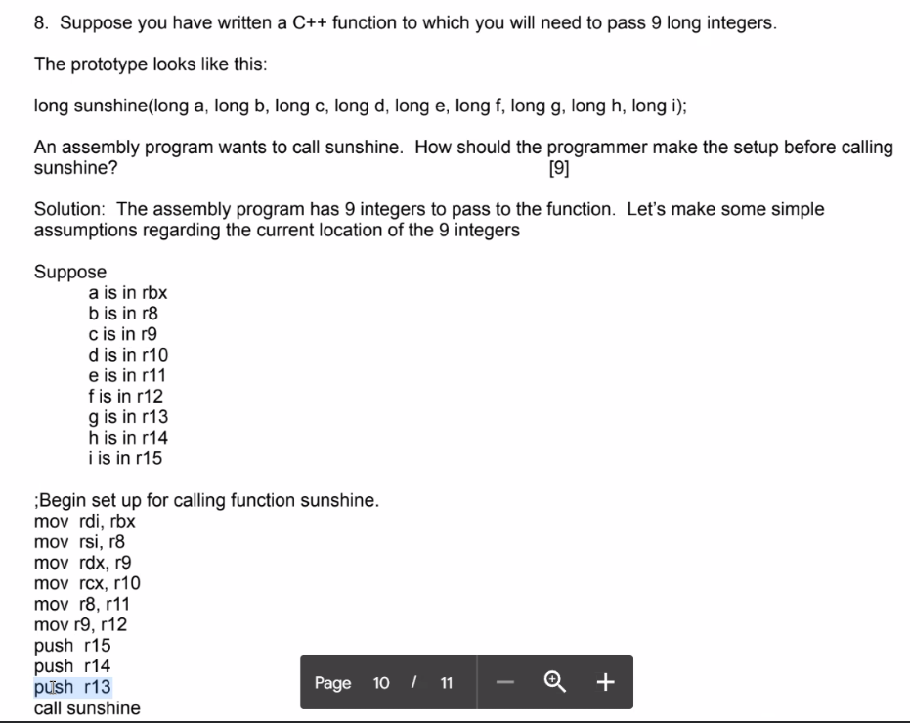

C13: System services. That means pure assembly.
You need to know all about syscalls, and how to link object file when developing a pure assembly program.

We only learning input and output syscalls, but there are a lot more
No file I/O

C14: Multiple source files
You have used the techniques of multiple source files since the semester began. You know all about the placement of “extern” and the placement of “extern”C” “.

extern “C” only on C++ files/function prototypes

In the textbook chapters 15, 16, and 17 will not be on the test.

C18: Instructions acting on xmm registers, properly known as the SSE set of registers. We assume that from your experience with the assignments you know all about using xmm registers: copy them, push them, pass them, operate on them
movsd
addsd
sqrtsd
ucomisd

In the textbook chapters 19 and 20 will not be on the test.

Topics not in the textbook but suitable for this test.

T1: Software licensing

GPL, LGPL, and CC good licenses according to Holiday
LGPL is for library functions (improved function that you want to share)
GPL is for general software (OS game)
CC is for books (want to publish a paper/book)

T2: CPU clock
How to read clock, compute elapsed time, call getfrequency

T3: Inline assembly
Know how to build your own block of x86 code and run it inline.
Are there any limitations?

There is only .text segment. There is no .data or .bss segment. Can’t declare own array, own format statement, therefore can’t call printf. Will have to compensate by doing these things in C++

T4: Syntaxes (plural).
Which syntaxes? How do you read ATT? Left to right? Or Right to left?

ATT - Left to right add $rbx, $rax
Intel – right to left add rax, rbx (how we’ve been doing it)

T5: How to add (or subtract) manually two float numbers. How to detect loss of precision during an addition.

T6: Computer culture
Charles Babbage
Ada Lovelace
George Boole, created xor instructions
Howard Atkins, first programmable computer in 1945-47
Grace Hopper, programmer for Mark I
Richard Stallman, OS activist
Linus Torvald, creator of linux kernel and git

T7: Assembly culture
Kathleen Booth: https://www.theregister.com/2022/10/29/kathleen_booth_obit/ first assembly programmer (British)
Chris Sawyer: http://www.chrissawyergames.com/ king of assembly programming
Chris Creel: https://www.youtube.com/@WhatsACreel king of assembly teaching

